Ideation Phase

Define the Problem Statements

Date | 31 OCTOBER 2025
Team ID | NM2025TMID09077
Project Name | Laptop Request Catalog Item
Maximum Marks | 2 Marks

- Customer Problem Statement :
Employees face delays and frustration when ordering laptops through the current ServiceNow catalog.
The existing catalog item lacks real-time stock validation, correct model descriptions, and clear approval routing. This results in:
  - Back-and-forth emails to clarify requirements
  - Orders for out-of-stock models that must be cancelled manually
  - Incomplete delivery information causing shipping errors
  - Shadow-IT purchases that bypass security standards They need an intuitive, self-service catalog item that:
✅ automatically shows only in-stock models with accurate specs
✅ routes approvals to the correct budget owner
✅ creates downstream fulfilment tasks for Procurement & IT
✅ provides end-to-end visibility for requesters and fulfiller teams
This will improve employee productivity, hardware compliance, and procurement cycle time.

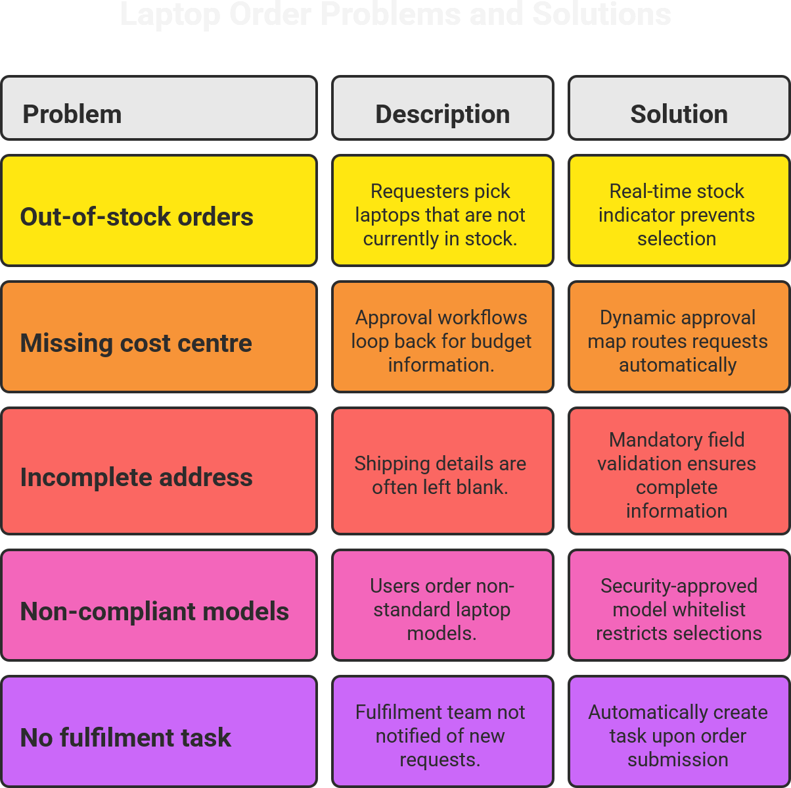

Example:

Problem Statement (PS) | I am (Customer) | I’m trying to | But | Because | Which makes me feel
PS-1 | A  Requester | Order my first Laptop | the catalog shows outdated models and lets me submit without  selecting a  cost centre | the item form is not synced with the asset database and lacks field validation | anxious and unproductive on my first day.

PS-2 | IT  Procurement Analyst | Fulfil laptop orders within the 5-day SLA | Requests  frequently arrive with missing  shipping addresses and wrong models that are out of  stock, | the current catalog item does not  validate stock or force address capture | Overwhelmed and reactive

Problem Statement PS 1:
As a new hire,
I’m trying to order my first laptop through the ServiceNow portal,
but the catalog shows outdated models and lets me submit without selecting a cost centre, because the item form is not synced with the asset database and lacks field validation, which makes me feel anxious and unproductive on my first day.
I need a catalog item that only displays available laptops, enforces data completeness, and gives me an ETA instantly.

Problem Statement PS 2:
As an IT Procurement Analyst,
I want to fulfil laptop orders within the 5-day SLA,
but requests frequently arrive with missing shipping addresses and wrong models that are out of stock,
because the current catalog item does not validate stock or force address capture,
which makes me feel overwhelmed and reactive, constantly chasing requesters for details.
I need the system to auto-check stock, enforce address capture, and generate a fulfilment task so I can focus on vendor management instead of data cleanup.

